**Fitbit: adding new participant to study**

1. Go to the Fitbit SDK website: <https://dev.fitbit.com/login>
2. Login with created Fitbit credentials for patient
3. Register a new app and configure to be the same as image file “Setup for fitbit apps.png”

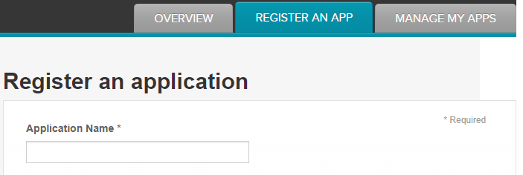

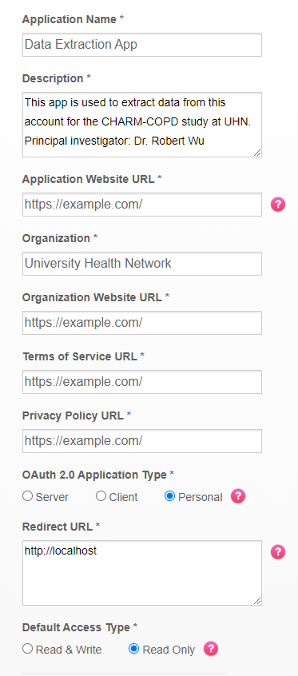

**The application name and description will need to be changed for the specific study.**

**Once this is set up:**

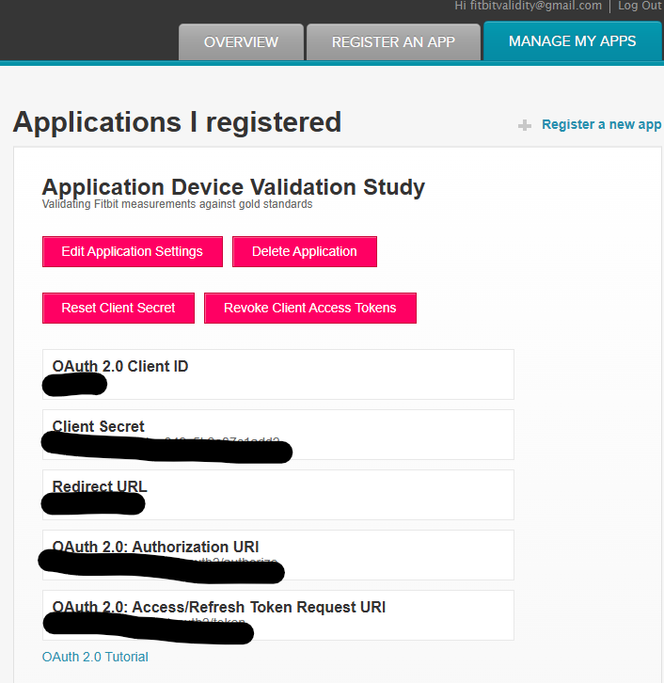

**Copy paste the client ID here:** https://www.fitbit.com/oauth2/authorize?response_type=token&client_id=[COPY PASTE]&redirect_uri=https://localhost&scope=activity%20heartrate%20location%20nutrition%20oxygen_saturation%20profile%20respiratory_rate%20settings%20sleep%20social%20temperature%20weight&expires_in=31536000

**Copy paste the URL into browser**

**Should get an error message (this is normal). Save the URL (should be localhost/#access_token=[access token]&user_id=[user ID]**

**Use the access token + user ID to run the script**